ASSIGNMENT-2.3

Name: chilukamari bhavya Hall-Ticket: 2403a51109

Batch No: 06 Course: AI Assisted Coding

Task Description#1

* Use Google Gemini in Colab to write a function that reads a CSV file and calculates mean, min, max.

Expected Output#1

* Functional code with output and screenshot.

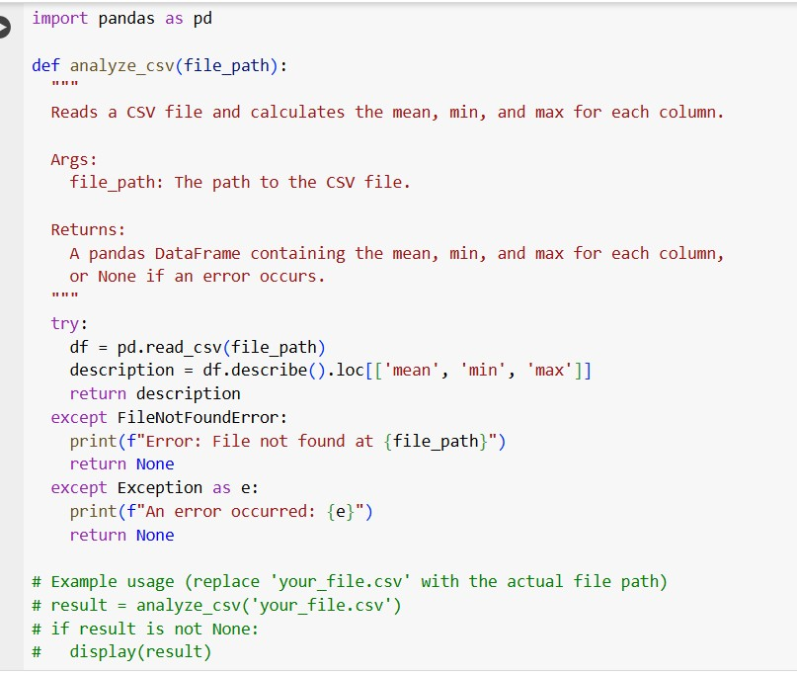

Explanation:

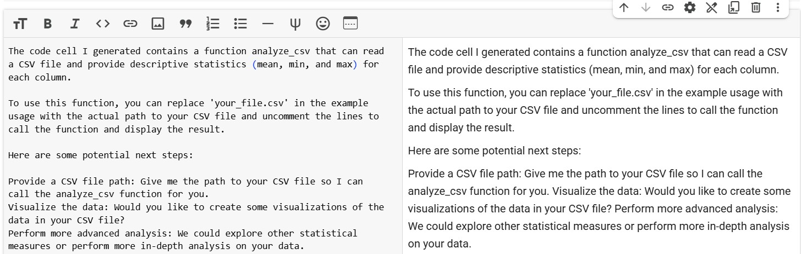

Compare Gemini and Copilot outputs for a palindrome check function.

Expected Output#2

* Side-by-side comparison and observations Gemini’s code:

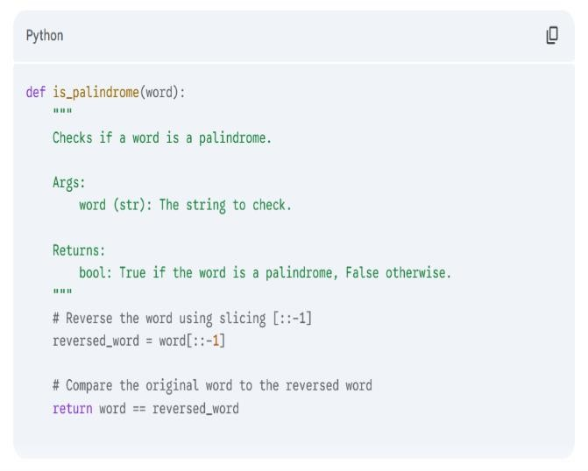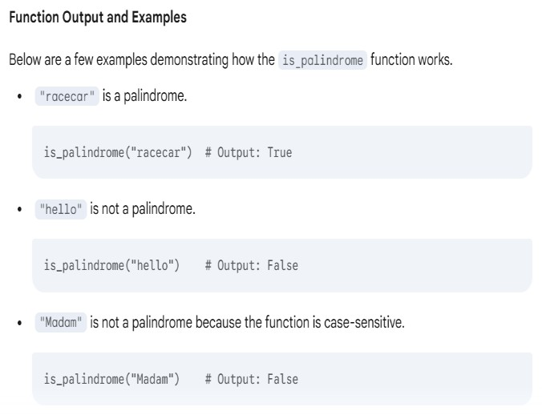

Copilots code:

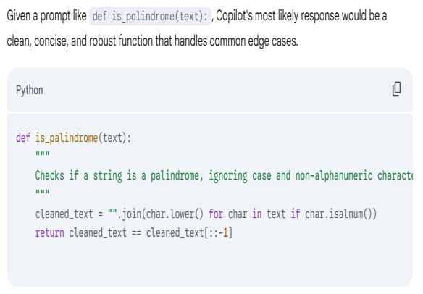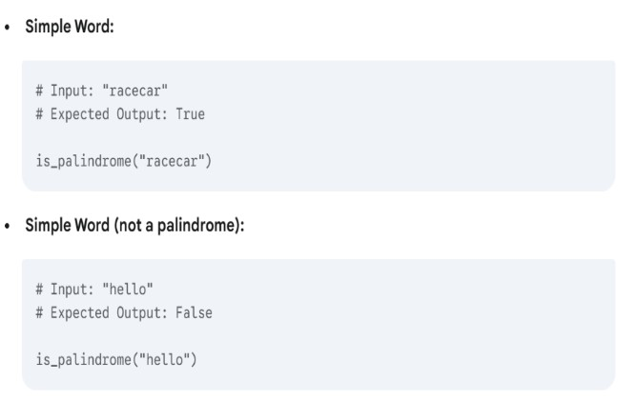

Side-by-side Comparisons and Observations:

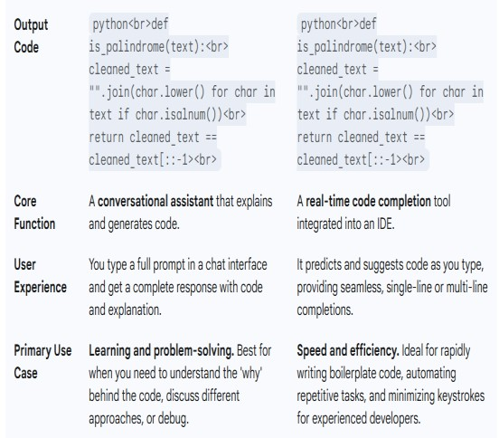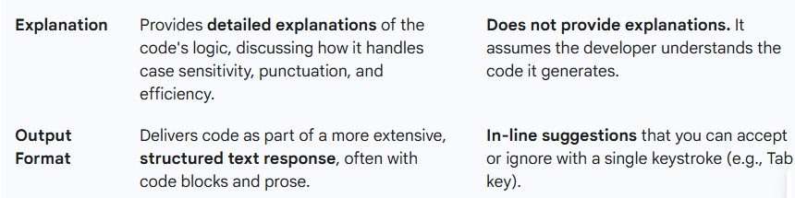

Ask Gemini to explain a Python function (to calculate area of various shapes) line by line..

Expected Output#3

* Detailed explanation with code snippet

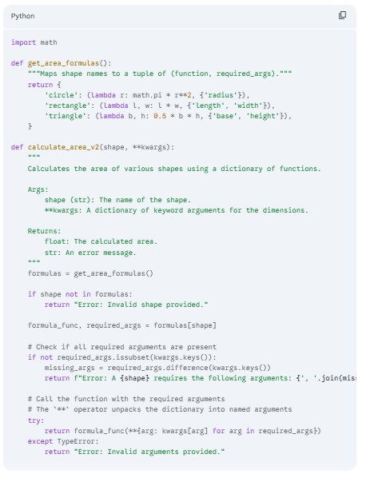

Explanation:

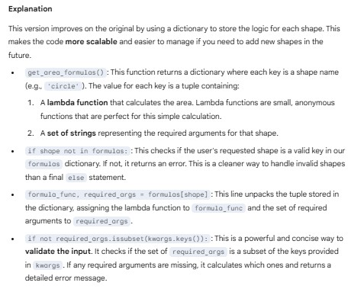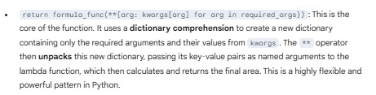

Install and configure Cursor AI. Use it to generate a Python function (e.g., sum of squares).

Expected Output#4

* Screenshots of working environments with few prompts to generate python code.

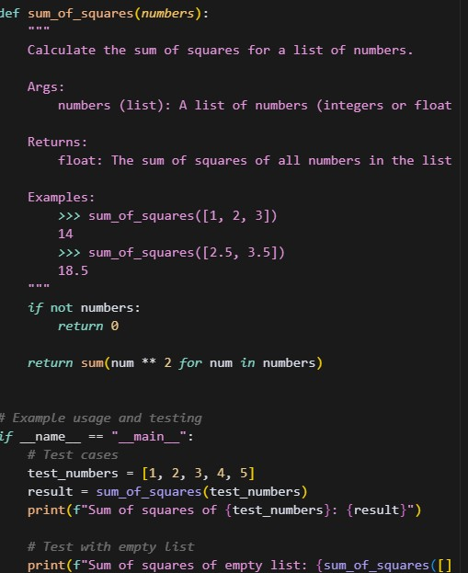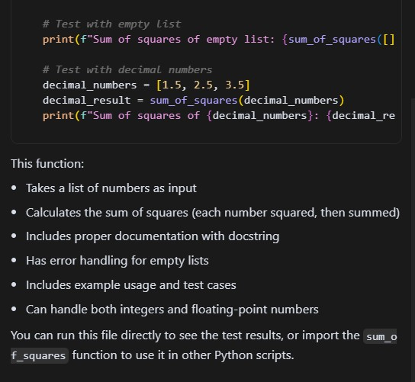

Explanation:

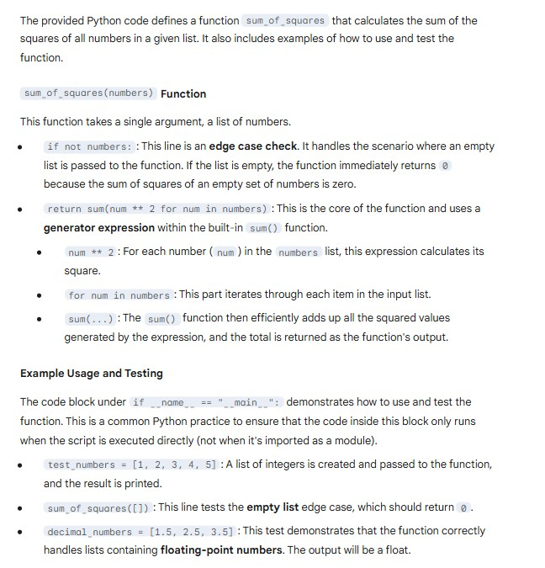

Student need to write code to calculate sum of add number and even numbers in the list

Expected Output#5

* Refactored code written by student with improved logic

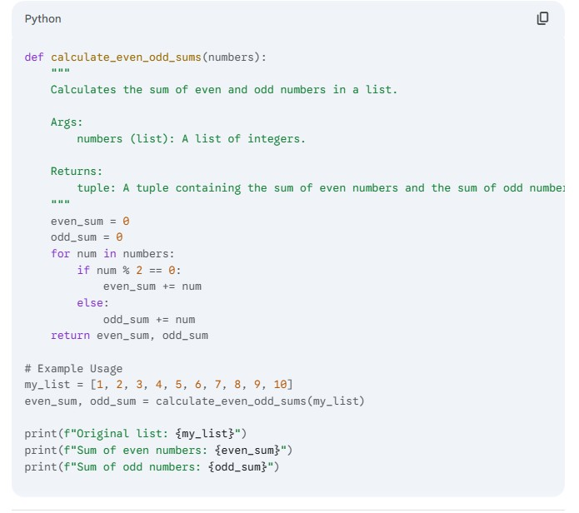

Explanation:

